IT7742 Assessment 2
Customer Management & Reliability

Chetan
20231047

Github repository link: https://github.com/chetannn2121/IT7742_Assessment2

Technical Report

UML Diagram
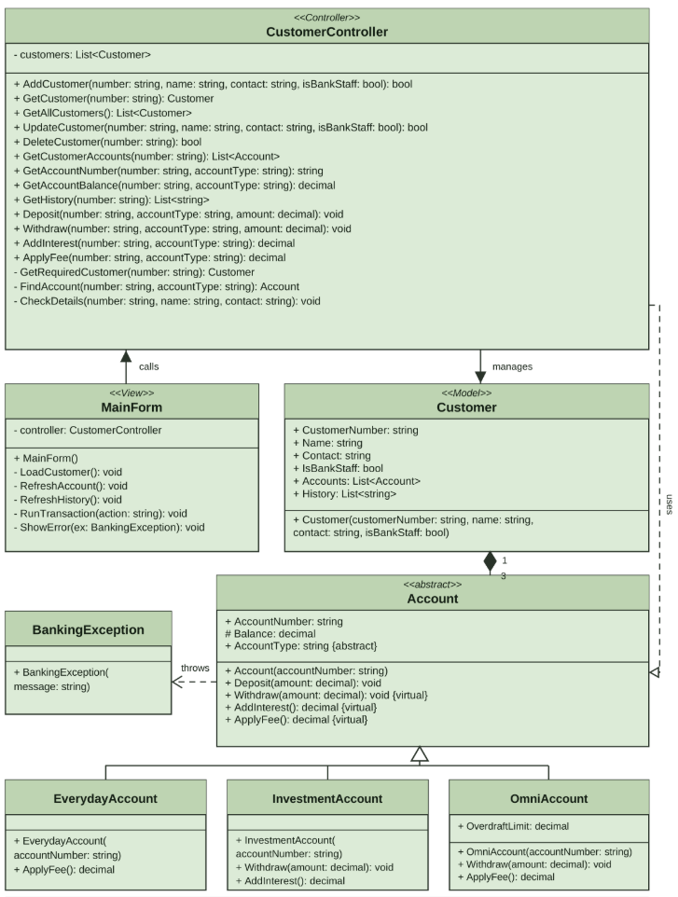

MVC Analysis Report
The UML class diagram shows how the banking application was created using the Model-View-Controller (MVC) pattern in Sprint 2. Windows Form is separated from customer data and banking operations. Customer collection is in CustomerController, and MainForm is responsible for getting user input and showing results.
The Customer class represents the Model. It stores the customer number, name, contact details, bank staff status, accounts and transaction history. The IsBankStaff finds staff customers without creating separate customer subclasses. Each Customer object creates an EverydayAccount, InvestmentAccount and OmniAccount. The filled diamond in the diagram shows this ownership relationship.
CustomerController is the main part of the design because it manages the customer list and provides methods for Create, Read, Update and Delete (CRUD). AddCustomer() checks the input and doesn't allow duplicate customer numbers. GetCustomer() searches for one customer, and GetAllCustomers() returns a list for display. UpdateCustomer() changes the name, contact and staff status. DeleteCustomer() removes a selected customer. These methods return a customer, a list or a Boolean value. Private methods such as CheckDetails() and GetRequiredCustomer() are used.
The Controller links customers to the Account classes. It finds the selected account and calls Deposit(), Withdraw(), AddInterest() or ApplyFee(). The abstract Account class provides shared properties and transaction behaviour as per the assignment details. EverydayAccount, InvestmentAccount and OmniAccount inherit from it and use their own rules for interest and overdraft calculation.
The MainForm class is the view. It reads text boxes, buttons and the selected account type, then calls CustomerController methods. It displays customer details, balances, transaction history and error messages. If Windows Forms is replaced with a console or web interface, the same Controller and Model classes could be reused.

Testing Strategy
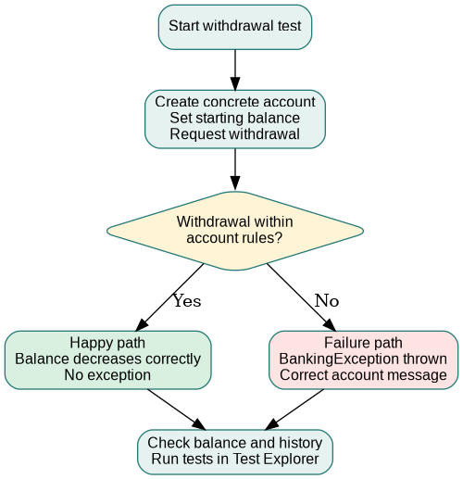

Test Results Table
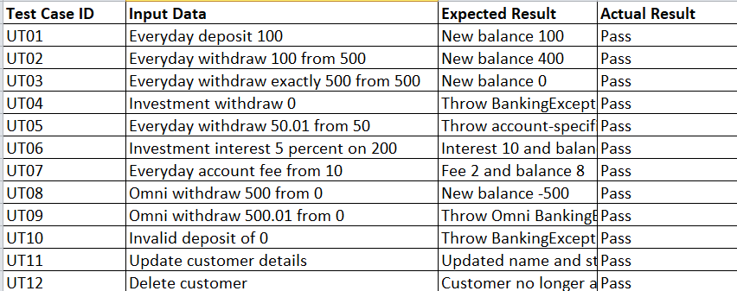

Run MS Test results

